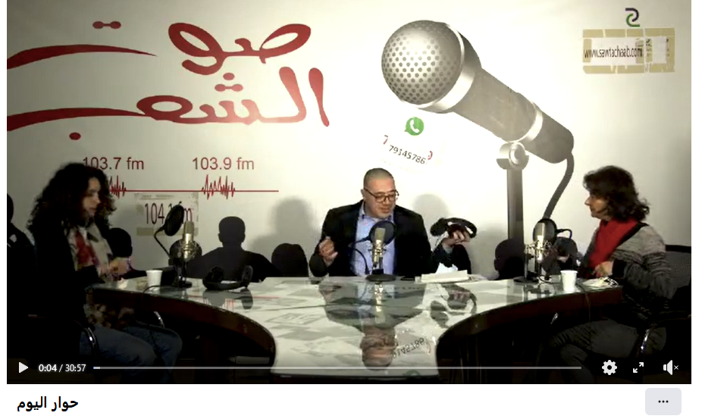

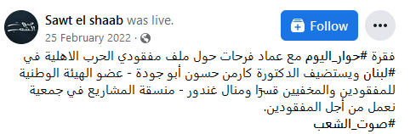

**Video URL:** <https://www.google.com/url?sa=t&rct=j&q=&esrc=s&source=video&cd=&cad=rja&uact=8&ved=2ahUKEwjYi6DtgM__AhVXUqQEHWrpBWEQtwJ6BAgEEAI&url=https%3A%2F%2Fwww.facebook.com%2Fsawtak%2Fvideos%2F%25D8%25AD%25D9%2588%25D8%25A7%25D8%25B1-%25D8%25A7%25D9%2584%25D9%258A%25D9%2588%25D9%2585%2F692133421814161%2F&usg=AOvVaw2uMl0unRhUVecWqUHUDeqb&opi=89978449>